**UNITED STATES AIR FORCE ACADEMY**

**DEPARTMENT OF ELECTRICAL AND COMPUTER ENGINEERING**

**ECE 332 Laboratory Exercise 16d**

**Band-Pass and High-Q Filter Design**

**1. Objective**

*The objective of this lab is to design two filters with desired characteristics to meet frequency response requirements:*

* *Cascaded first-order broadband.*
* *Second order, high Q.*

**2. Specifications and Limitations**

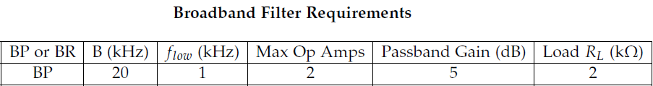

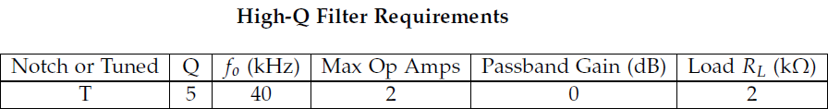

**3. General Approach**

*The general method in determining component values was comparing general transfer functions for the intended circuit in the s-domain with those in the time domain, consisting of component values, and solving within our given specifications.*

**4. Design**

**a. Mathematical Equation**

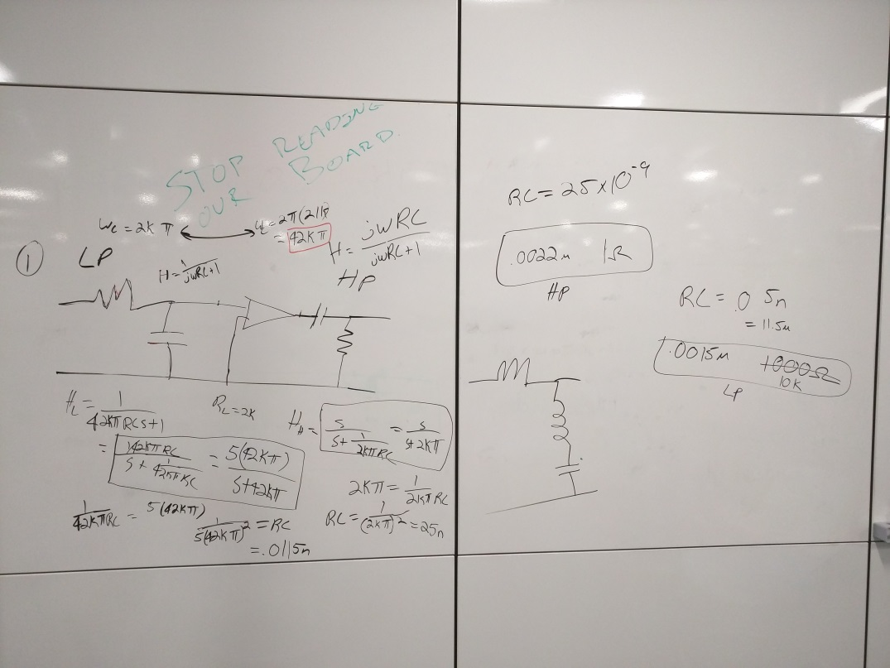

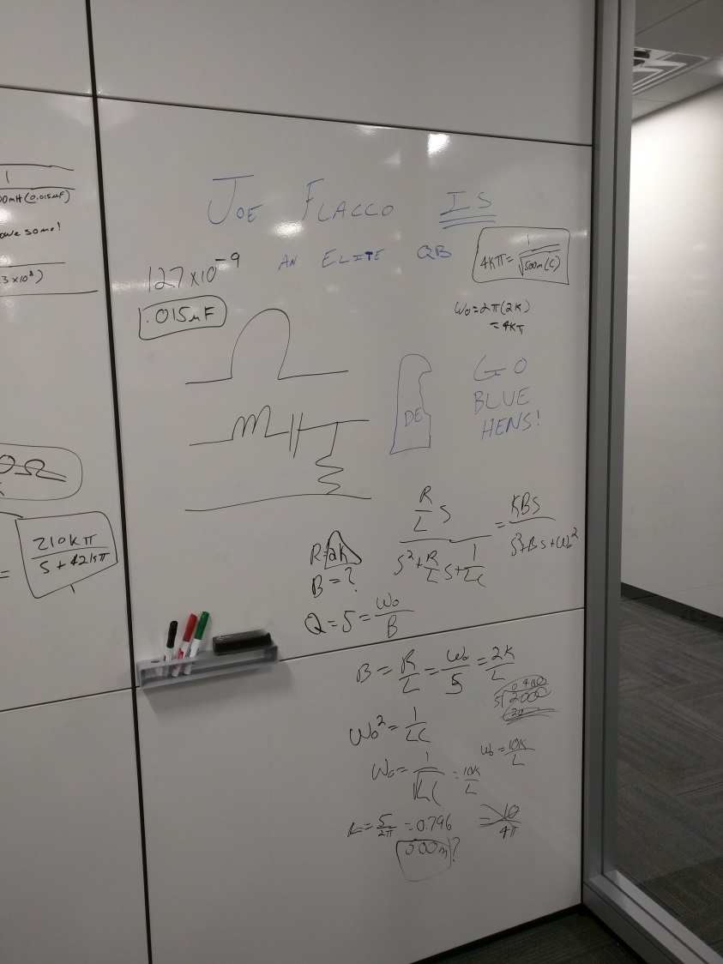

Broadband:

High-Q:

**b. Circuit Simulation**

Broadband Filter

format compact

s = tf('s');

H1 = ((210000*pi)/(s+(42000*pi))) * (s/(s+(2000*pi)));

bode(H1)

grid on

title('Bode Plot for Broadband')

simplify(H1)

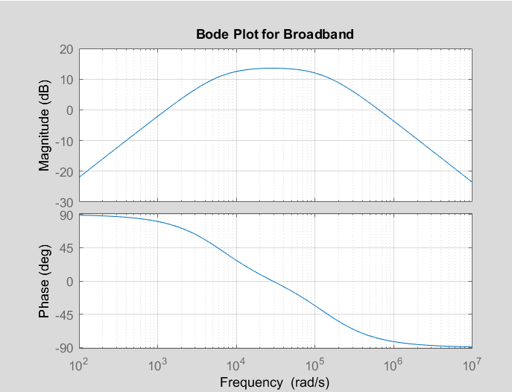

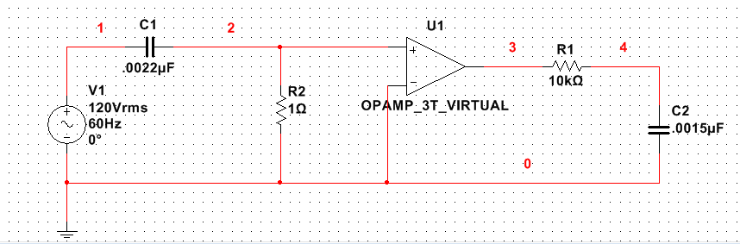

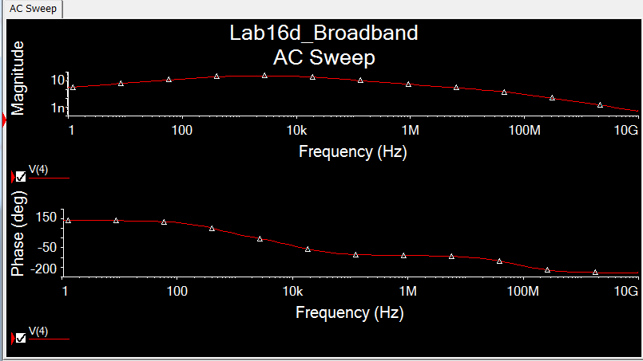

High-Q Filter

s = tf('s');

h2 = (4000*s)/(s^2 + 4000*s + (1.3*(10^8)));

figure

bode(h2)

grid on

title('Bode Plot for High-Q')

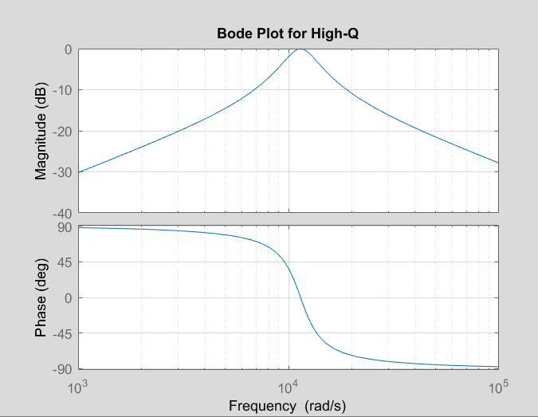

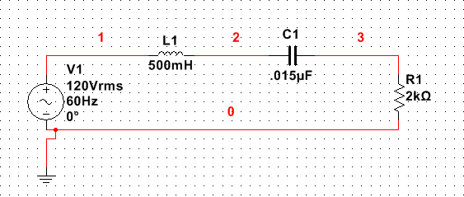

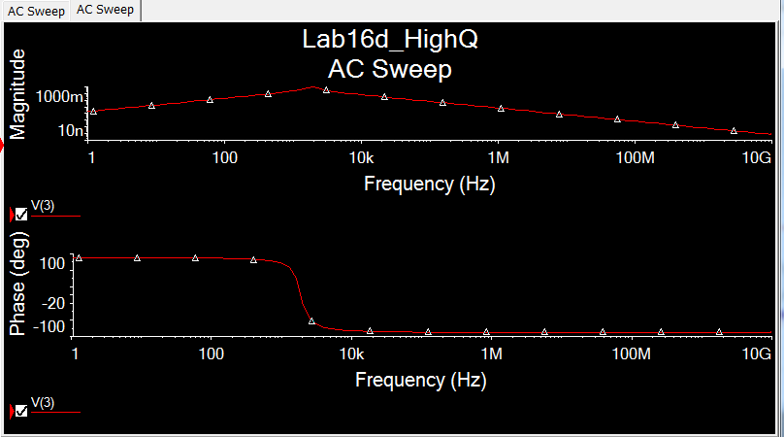

**5. Implementation**

Broadband:

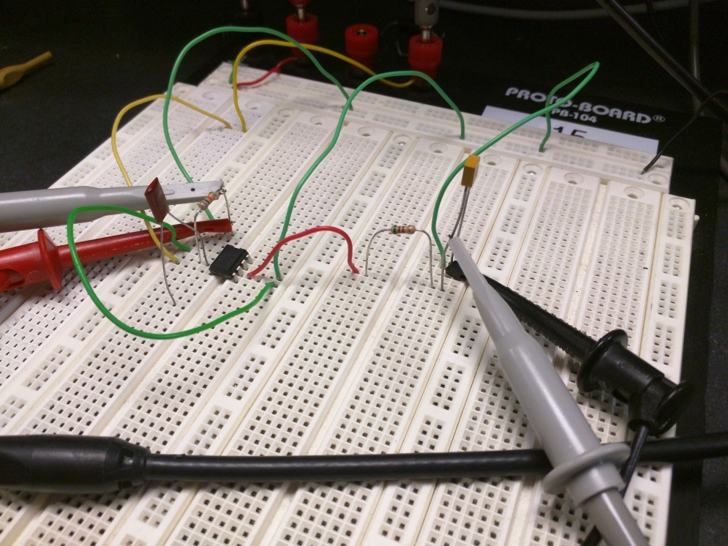

High-Q:

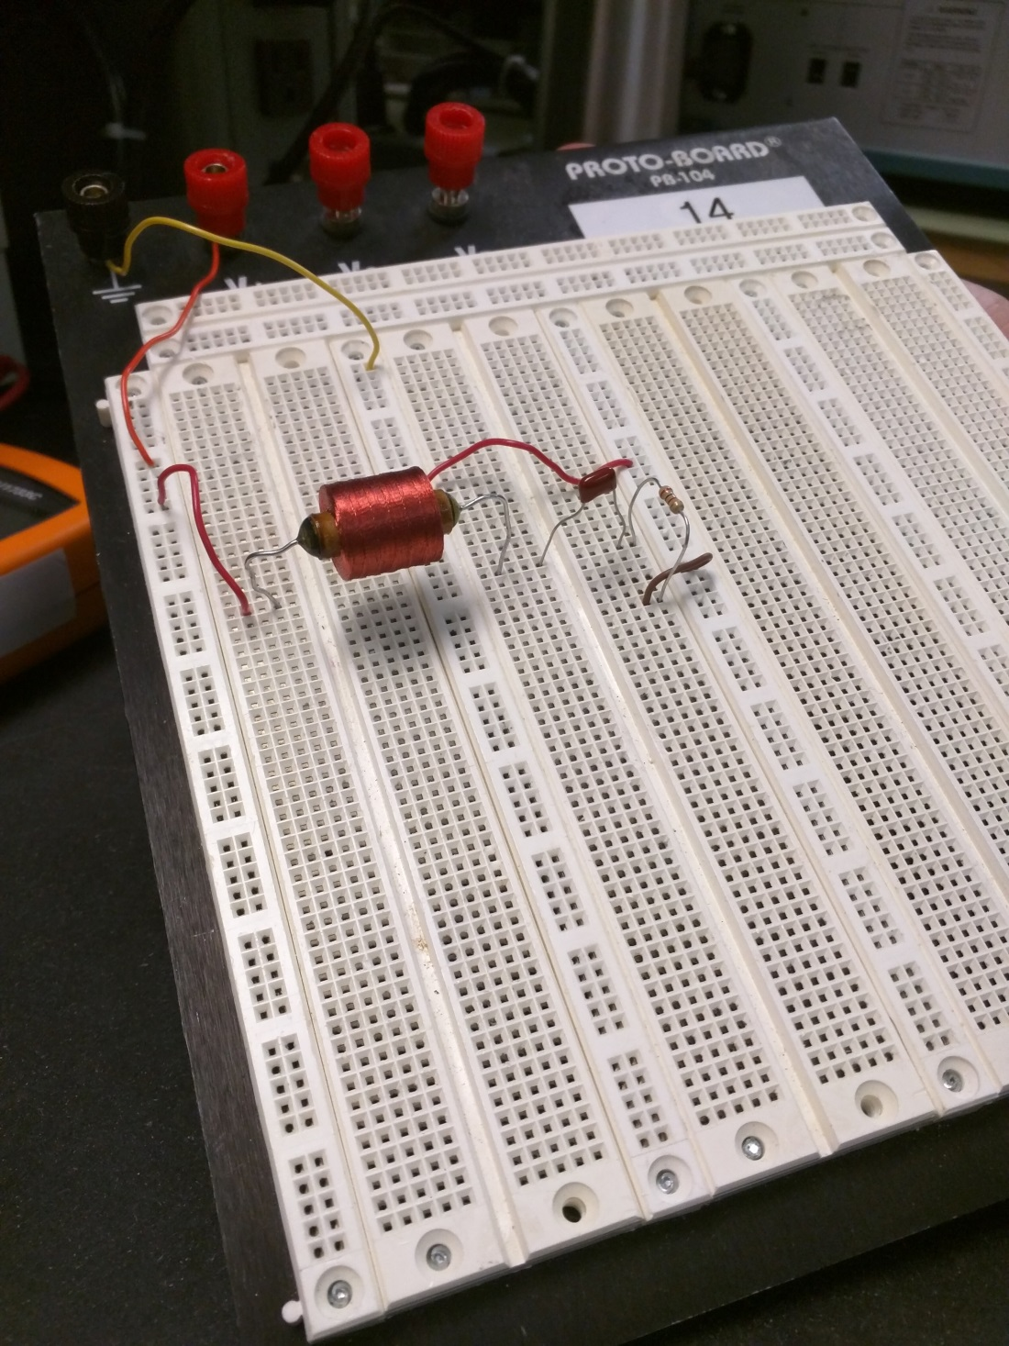

**6. Analysis and Testing**

Broadband Oscilliscope:

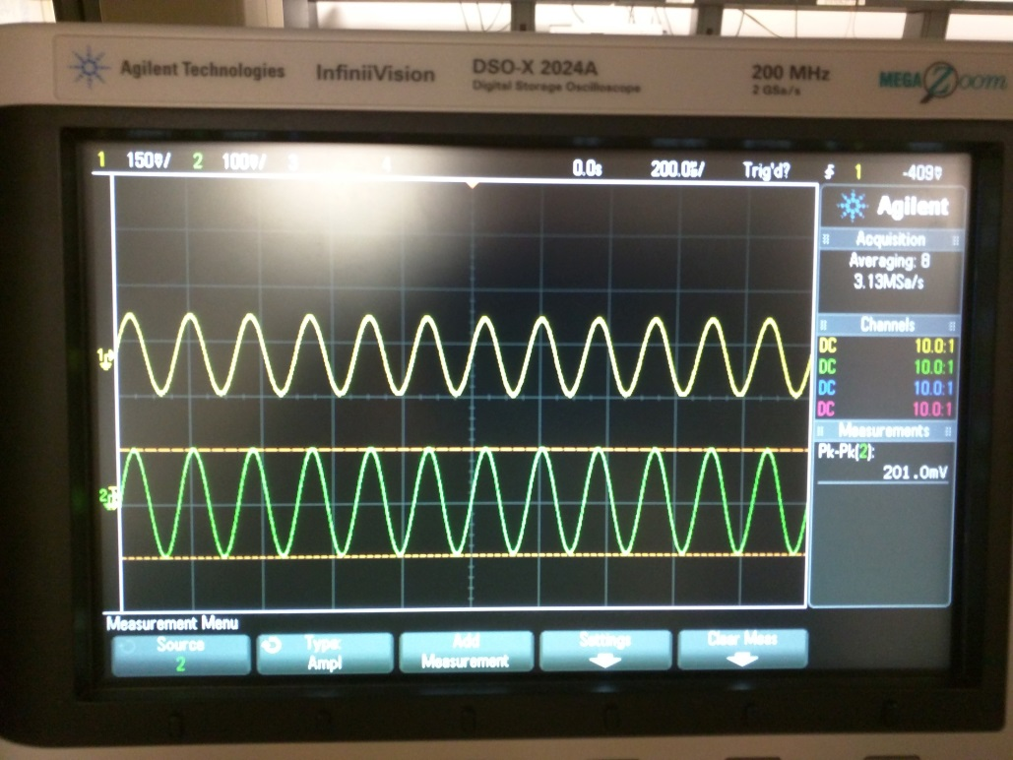

|  |  |  |  |  |  |
| --- | --- | --- | --- | --- | --- |
| **Parameter** | **Specifications** | **Calculation** | **% Error** | **Simulation** | **% Error** |
| B (kHz) | 20 | 21.6 | 8 | ~ | ~ |
| flow (kHz) | 1 | 0.93 | 7 | ~ | ~ |
| Max Op Amps | 2 | 1 | ------------- | 1 | ------------- |
| Passband Gain (dB) | 5 | 13.6 | 172 | ~ | ~ |
| RL (Ω) | 2 | --------------- | ------------- | 2 | ------------- |
| **Parameter** | **Specifications** | **Actual** | **% Error** |
| B (kHz) | 20 | ~ | ~ |
| flow (kHz) | 1 | ~ | ~ |
| Max Op Amps | 2 | 1 | ------------- |
| Passband Gain (dB) | 5 | ~ | ~ |
| RL (Ω) | 2 | ~ | ~ |

High-Q:

|  |  |  |  |  |  |
| --- | --- | --- | --- | --- | --- |
| **Parameter** | **Specifications** | **Calculation** | **% Error** | **Simulation** | **% Error** |
| Q (-) | 5 | ~ | ~ | ~ | ~ |
| f0 (kHz) | 40 | 2.73 | 93.2 | ~ | ~ |
| Max Op Amps | 2 | 0 | ------------- | 0 | ------------- |
| Passband Gain (dB) | 0 | ~ | ~ | ~ | ~ |
| RL (Ω) | 2 | --------------- | ------------- | 2 | ------------- |
| **Parameter** | **Specifications** | **Actual** | **% Error** |
| Q (-) | 5 | ~ | ~ |
| f0 (kHz) | 40 | ~ | ~ |
| Max Op Amps | 2 | 1 | ------------- |
| Passband Gain (dB) | 0 | ~ | ~ |
| RL (Ω) | 2 | ~ | ~ |

**7. Conclusions**

*We did not understand this lab. To make matters worse, when attempting the pre-lab we initially had the incorrect specifications for our High-Q design, hence the 93% error and much confusion. After devoting 3 hours in the library to trying to design the correct circuit, only to have to start again, morale was low and intelligence was affirmed even lower. Again and again, we thought we knew what we were doing, only to ask for guidance and be diverted back to the pre-lab given the immense discrepancy between our design and the specifications. After continually believing we might be able to sort it out, this is what we have assembled from the little comprehensible material we had. Mistakes were made, but grave lessons were learned. In the future, we will seek gratuitous help from the start.*

**Documentation: None**